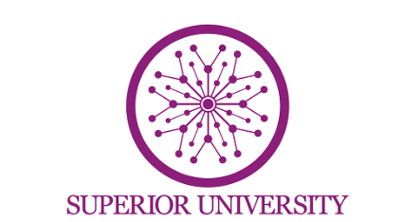
Name: Muzamil Mushtaq
Roll no: SU92-BSAIM-F24-037
Section: BSAI-4A
Submitted to: Sir Rasikh Ali
Lab_Task_10
University Admission Chatbot (Flask-Based Web Application)
Introduction:
The University Admission Chatbot is a web-based application developed using Flask (Python framework) for the backend and HTML/CSS for the frontend. The purpose of this chatbot is to assist students by providing instant information about university admissions, such as eligibility criteria, available programs, fee structure, and deadlines.
This chatbot simulates a real-time conversation between a user and a system. It reduces the need for manual inquiries and helps students get accurate information quickly. The system uses basic Natural Language Processing (NLP) techniques to understand user queries and generate appropriate responses.
Objectives:
- To develop an interactive chatbot using Flask.
- To provide quick access to university admission information.
- To enhance user experience through a web-based interface.
- To demonstrate basic NLP concepts in a real-world application.
Technologies Used:
- Python (Flask) for backend development.
- HTML for structure of the web page.
- CSS for styling and design.
- JavaScript for handling user interaction and API requests.
Working of the System:
- The user enters a query in the chatbot interface.
- The message is sent to the Flask backend.
- The backend processes the input using predefined conditions.
- The chatbot generates a response.
- The response is displayed on the frontend.
Features of the Chatbot:
- Interactive chat interface
- Instant responses
- User-friendly design
- Handles multiple queries such as:
  - Admission requirements
  - Programs offered
  - Fee structure
  - Deadlines
Advantages:
- Provides instant information without human involvement.
- Available 24/7 for students.
- Reduces workload of university staff.
- Easy to use and user-friendly.
- Can be expanded with AI for smarter responses.
- Saves time for both students and administration.
Disadvantages:
- Limited understanding of complex queries.
- Works only on predefined responses (rule-based system).
- Cannot handle ambiguous or unclear questions.
- Requires updates to add new information.
- Not as intelligent as advanced AI-based chatbots.

Future Improvements:
- Integration with advanced NLP libraries such as Text Blob or AI models .
- Voice input and speech recognition.
- Database integration for dynamic data.
- Multi-language support.
- Deployment on cloud platforms for real-world use.
Conclusion:
The University Admission Chatbot is a simple yet effective application that demonstrates how web technologies and NLP can be combined to solve real-world problems. It improves accessibility to information and enhances user interaction. Although it has some limitations, it can be further improved by integrating advanced AI techniques, making it more intelligent and efficient.

Thank you for viewing my work….

